- VLAN trunking & Access Ports Theory

Q1. In Cisco Packet Tracer, configure two switches (Switch1 and Switch2) and connect them with a crossover cable. Set the FastEthernet0/1 port on both switches as trunk ports using the 802.1Q protocol?

Answer
- I connected two Cisco multilayer switches using a crossover cable in Cisco Packet Tracer.
- I configured FastEthernet0/1 on both switches as trunk ports using 802.1Q encapsulation.
- I verified the trunk configuration using the show interfaces trunk command.
- Result: The trunk port was successfully configured and showed the status as "trunking".
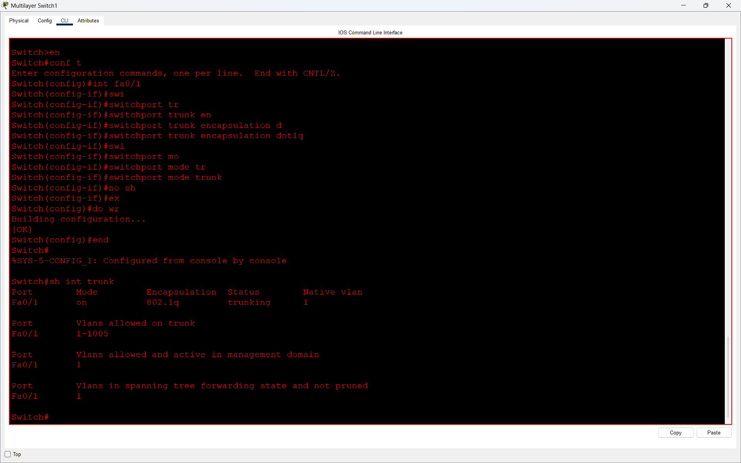

Q2. Create three VLANs (10, 20, 30) on both switches and assign FastEthernet0/2, 0/3, and 0/4 on Switch1 to VLAN 10, 20, and 30 respectively as access ports?

Answer
- I created three VLANs (10, 20, and 30) on both multilayer switches in Cisco Packet Tracer.
- I named VLAN 10 as HR, VLAN 20 as Admin, and VLAN 30 as Marketing.
- I assigned switch ports to the VLANs using the switchport mode access and switchport access vlan commands.
- I verified the configuration using the show vlan brief command.
- Result: All three VLANs were successfully created and activated on both switches.
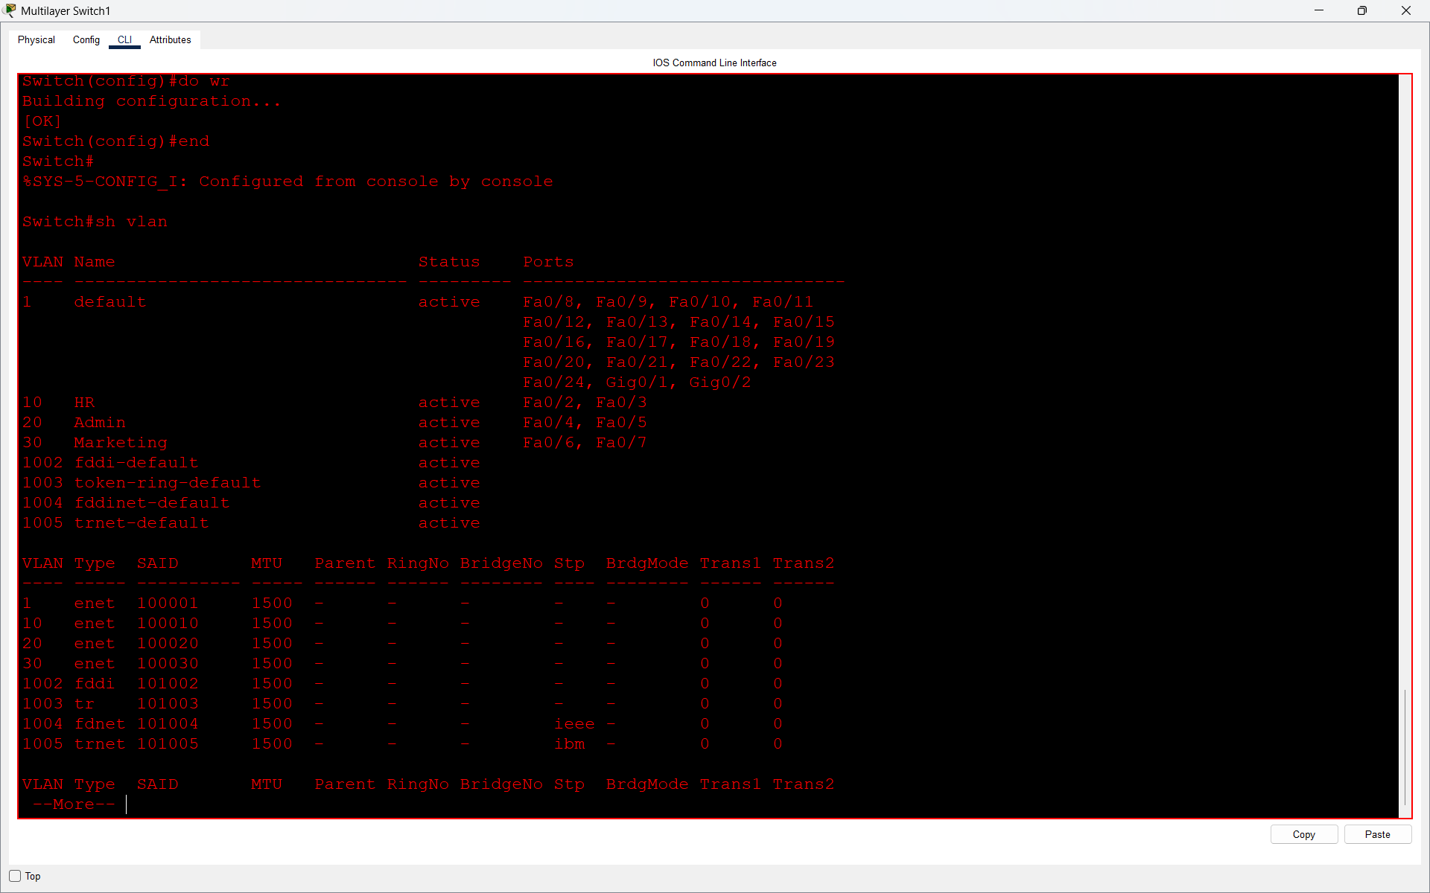
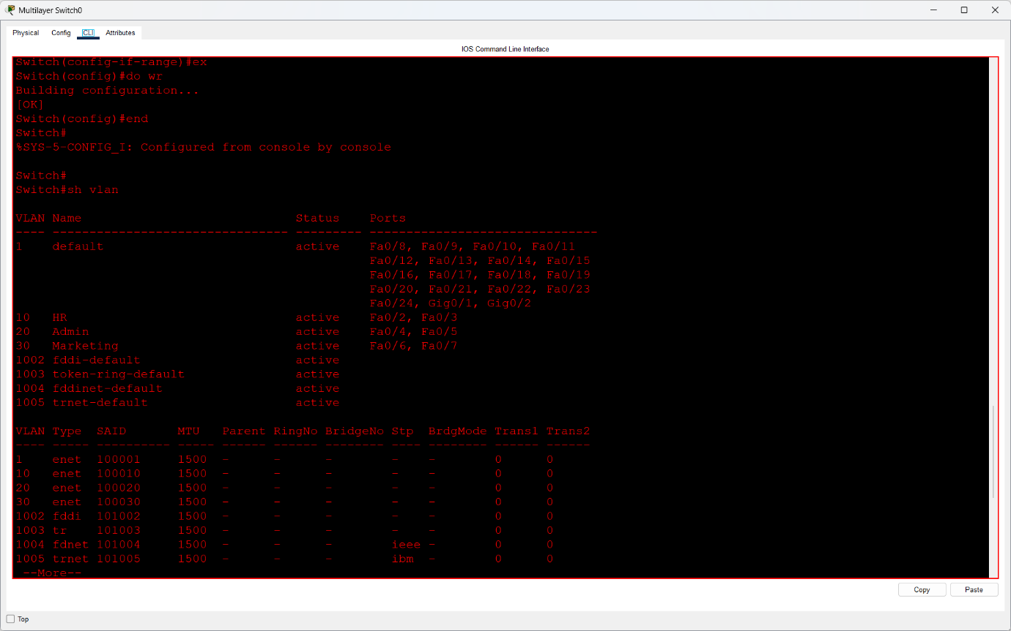

Q3. Connect three PCs to Switch1 on ports assigned to VLAN 10, 20, and 30. Verify that PCs in different VLANs cannot communicate with each other, but can communicate with other PCs in the same VLAN?

Answer
- I connected PCs to both multilayer switches and assigned them to VLAN 10, VLAN 20, and VLAN 30.
- I assigned static IP addresses to the PCs and tested connectivity using the ping command.
- The ping between PCs in the same VLAN was successful, while the ping between PCs in different VLANs failed.
- This shows that VLANs separate network traffic and inter-VLAN communication requires routing.
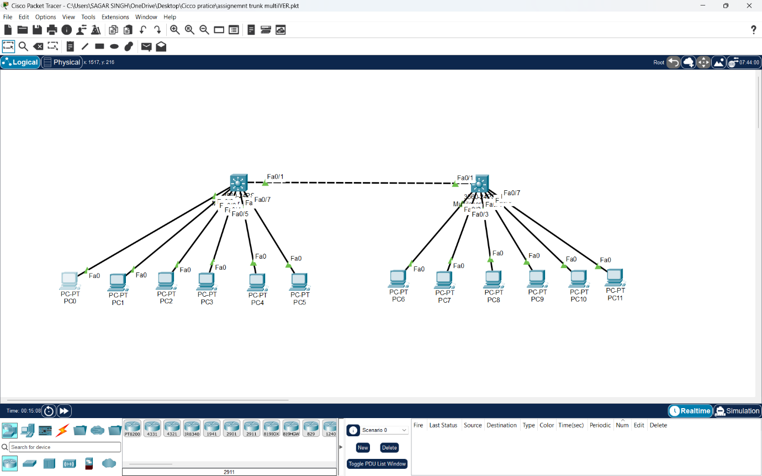
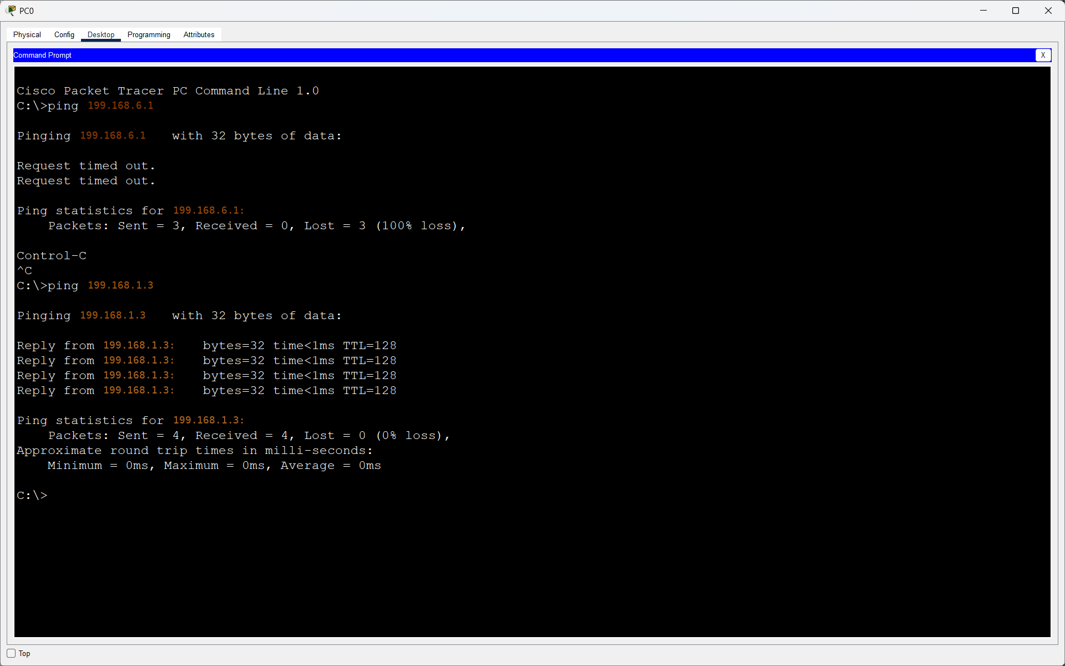
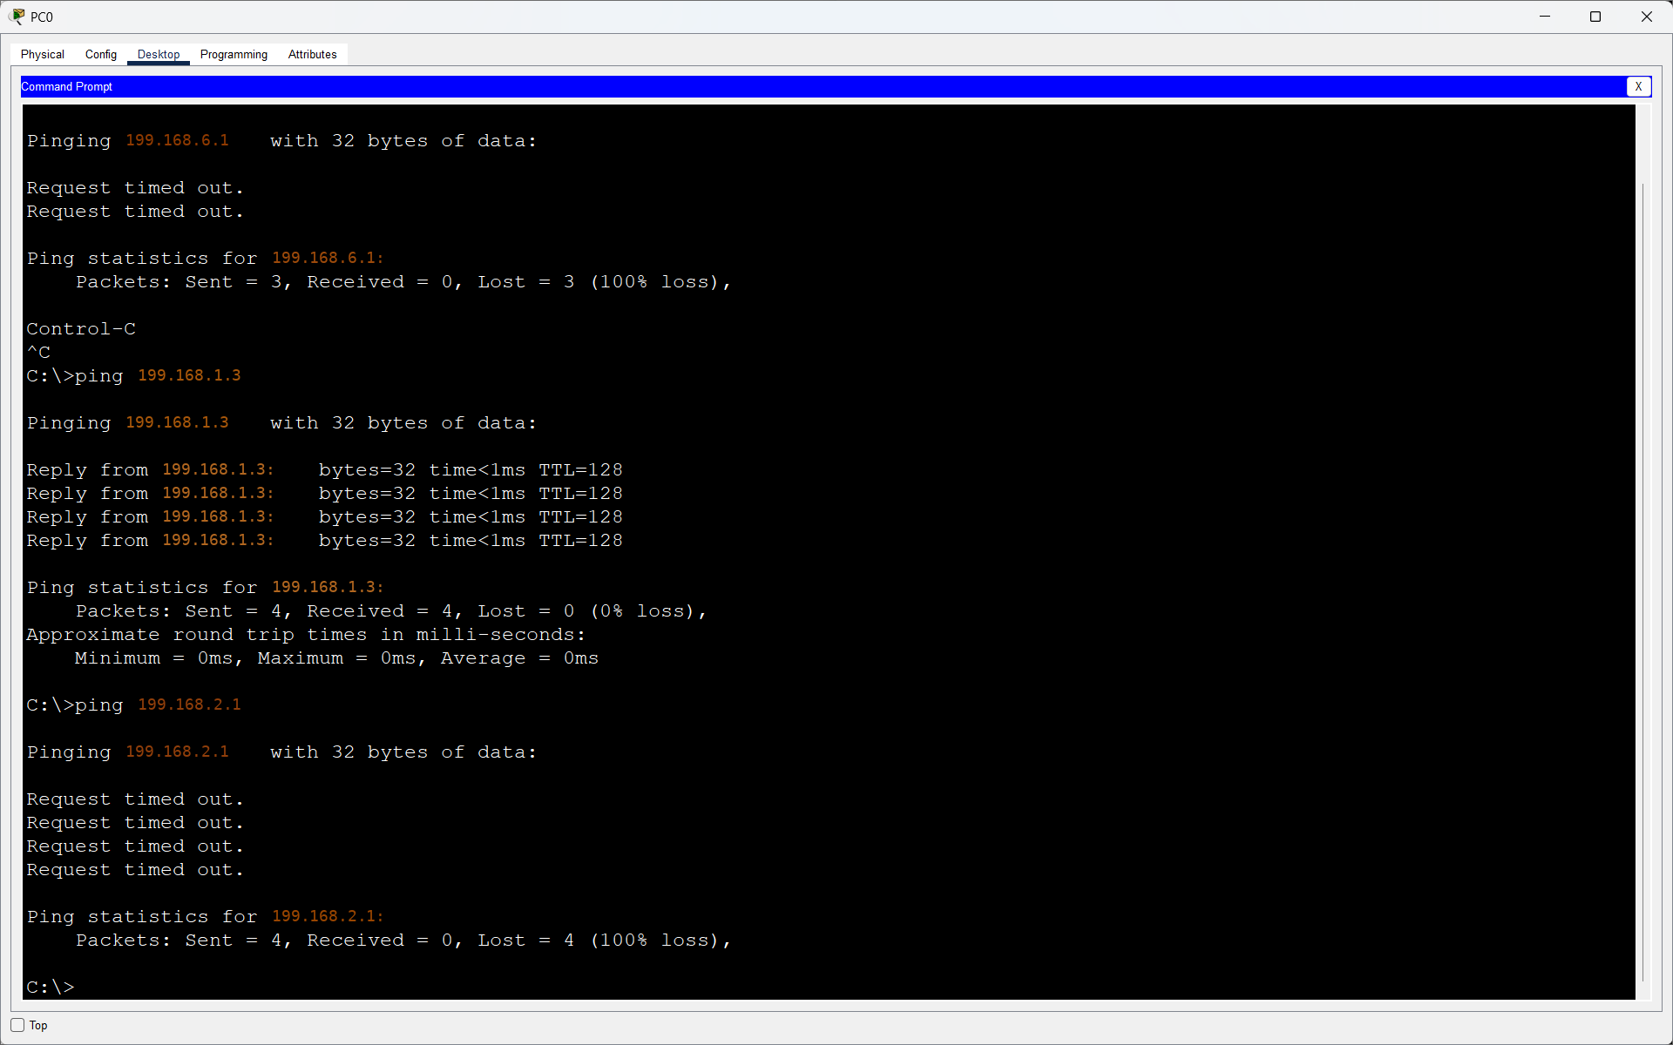

Q4. Change the trunk encapsulation on the trunk link between Switch1 and Switch2 from 802.1Q to ISL, and test if VLAN traffic still passes between the switches.<br><br><em><strong>Hint:</strong> Use the 'switchport trunk encapsulation isl' command before setting the port to trunk mode.</em>?

Answer
- I tried to change trunk encapsulation from 802.1Q to ISL, but the switch showed an invalid input error.
- I restored 802.1Q trunking and verified it using the show interfaces trunk command.
- After that, I tested connectivity between PCs. The same-VLAN ping was successful with 0% packet loss.
- Result: ISL was not supported, but VLAN communication worked successfully using 802.1Q.

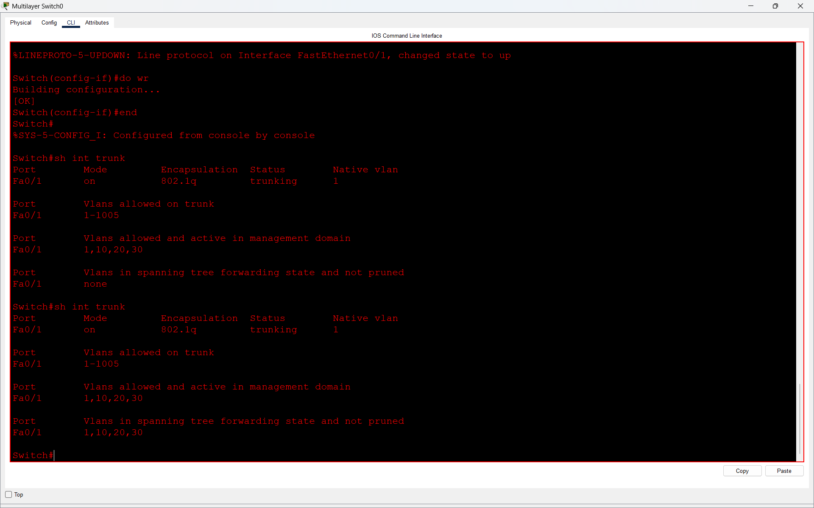

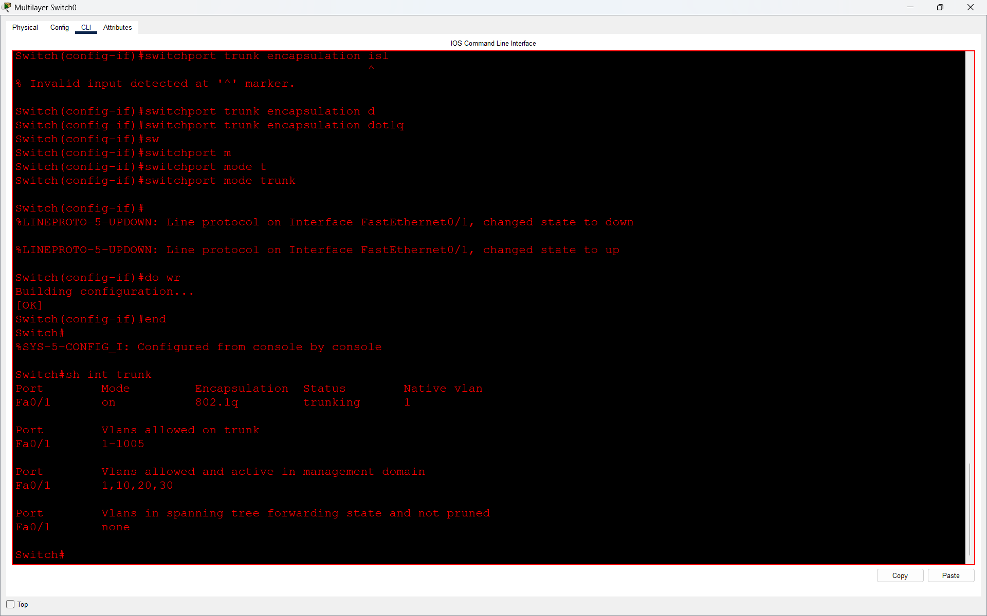
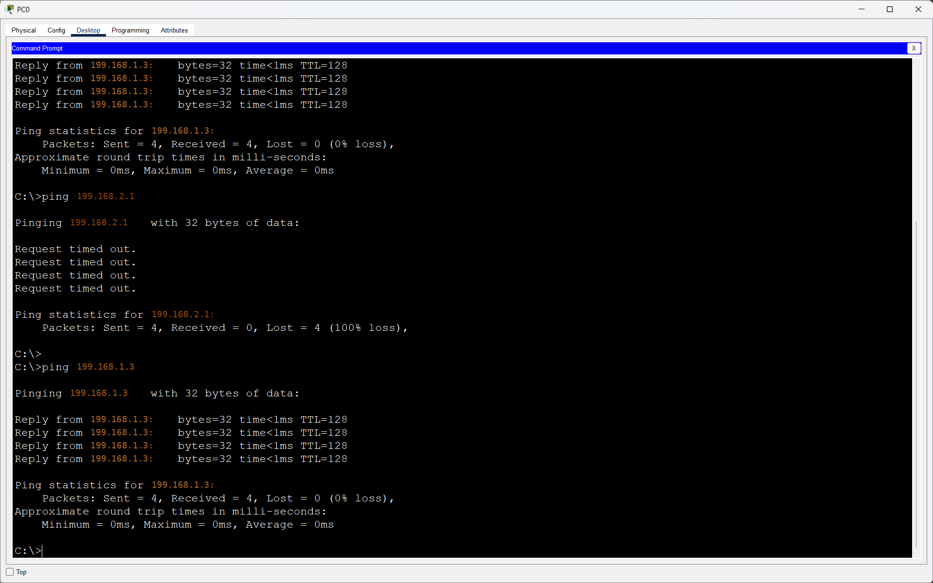

Q5. Simulate a scenario where a new port on Switch2 (FastEthernet0/5) is accidentally set as a trunk port instead of an access port for VLAN 20. Observe and explain the impact on connectivity for a PC connected to that port?

Answer
- I accidentally configured FastEthernet0/5 as a trunk port instead of an access port for VLAN 20.
- After changing the port to trunk mode, I tested connectivity and observed that the ping failed with 100% packet loss.
- I then changed the port back to access mode and assigned it to VLAN 20.
- After correcting the configuration, the ping was successful with 3 out of 4 replies.
- Result: Incorrect trunk configuration affected PC connectivity, and restoring the access port configuration fixed the problem.
